***Mobile Computing***

***Lecture No 3***

Task: Create account on github

* Download github for desktop or search github signup on your chrome.
* Enter your username
* Set your password
* Confirm validation
* Click on create “github account” button

**Task: Create repository**

* Click on “+” sign in profile
* A pop up menu will appear
* Select “create repository”
* A new window will appear
* Enter your repository name
* Make your repository “public” if you want to share it with other people

Or

Make private if you don’t want to share your data with others

* Click on “create repository” button.

Task: Github Commands

1. Git clone

Git clone is used to synchronize local repository to main repository.

Git clone is used to synchronize multiple repositories to share data among them.

1. Git add

Git add is used to add content to our repository

1. Git commit

Git commit is used to insert a message with addition of any content to our repository.

Example : git commit –m “first commit”

1. Git status

Git status is used to know the status of any repository.

1. Git push

Git push is used to make changes to the server.

1. Git pull

Git pull is used to retrieve the steps to be performed during the process.

It get changes from github to local repository.

1. Merge Conflicts

This is a type of error which occur when two people want to make changes to the same content.

1. Git log

Git log is used to get details of all commits in a repository.

Branching

Branching is a process in which a project or task is divided into subtasks or branches. These branches or sub-tasks are tested separately.

If any branch is completed or tested then it is murged with the main branch.

In concept of branching we use

* Git branch
* Git check
* Git merge

***Mobile Computing***

Mobile Computing is an umbrella term used to describe technologies that enable people to access services anytime and anywhere.

***Goals of Mobile Computing***

Basic goals of mobile computing is to make people be able to access information and communicate with each other easily and securely. They can also exchange information like data, images, audios and videos etc anytime, anywhere, in a timely coast effective way.

***Why we use mobile?***

There are many benefits of using mobile. Some of them are

* Portability
* Miniaturization
* Connectivity
* Convergence
* Digital Ecosystem

***Mobile Computing Limitations***

* Range and bandwidth
* Security Standards
* Power consumption
* Transmission interfaces
* Potential health hazards
* Human interface with device

***Lecture No 4***

***How we can create a new project in android studio?***

To make a project on Android studio we should follow these steps

* Click on start a new project
* Choose your project
* Configure your project by Assigning a name, Package name which should be uniquely identify and location where you want to save your project.
* Click on “ finish” button

Then you will see the platform for android studio where you will get

* File structure
* Coding
* GUI
* Resources
* Build gradle (project)
* Build gradle (module app)
* TODO
* Terminal
* Build
* LogCat
* AVD Manager
* Available Virtual devices
* Create virtual devices
* Run on virtual devices
* Launched
* Design and blueprint
* XML design view
* XML text view
* Constraint layout

And many other tools which help to make your applications.

***Lecture No 5***

***View***

A view usually draw something the user can see and interact.

A view objects are usually called “widgets” and can be one of many sub-classes, such as Button or textview.

***ViewGroup***

A vie group Invisible container. A view group objects are usually called “layouts” can be one of many types that provides a different layout structure such as Linear layout or Constraint layout.

***Constraint Layout***

To define a view's position in Constraint Layout, you must add at least one horizontal and one vertical constraint for the view.

***Add or Remove Constraint***

We can add or remove constraints for better performance and visibility.

***Lecture No 6***

***Activity***

* An Activity is an application component
* Represents one window, one hierarchy of views
* Typically fills the screen, but can be embedded in other Activity or a appear as floating window
* Java class, typically one Activity in one file

***Functions of Activity***

* Represents an activity, reciting “surah”, sending email, dialing number
* Handles user interactions, such as button clicks, text entry, or login verification
* Can start other activities in the same or other apps
* Has a life cycle—is created, started, runs, is paused, resumed, stopped, and destroyed

***Intent***

* An Intent is a description of an operation to be performed. An Intent is an object used to request an action from another app component via the Android system.

Originator -🡪 Intent --🡪 Action -> Intent ->App Component

***Intent can do***

* Start an Activity
  + **A button click starts a new Activity for text entry**
  + **Clicking Share opens an app that allows you to post a photo**

* Start a service
  + Fetching data in the background
* Deliver Broadcast
  + The system informs everybody that the phone is now charging

***Explicit and implicit intents***

* Explicit Intent
  + **Starts a specific Activity**
    - **Main activity starts Surah Activity**
    - **Main activity starts Parah Activity**
* **Implicit Intent**
  + **Asks system to find an Activity that can handle this request**
    - **Multiple options for sharing**

***Lecture No 8***

***Android Adapters***

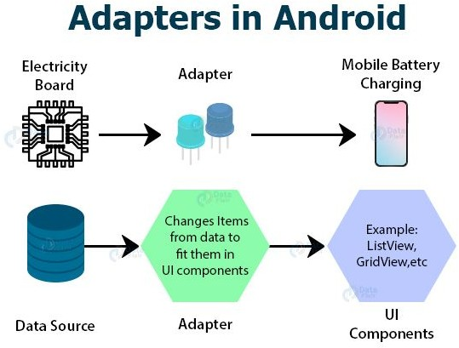

***Update of Records***

arrayAdapter.notifyDataSetChanged();

***Sorting of Records***

Collections.*sort*(**friendArraylist**);

Lecture No 9

***Animation***

To move, reveal or hide views within the current layout. You can use the property animation system provided by the android animation package, available in Android 3.0 and higher.

Android can add visual cues that notify user’s going on in your app. They are especially useful when the UI changes state, such as when new content loads or new actions become available. Animations also add a polished look to your app which gives it a higher quality look and feel.

***Types of Animations***

* Linear Animation
* Non-linear Animation

Lecture No 10

We learn to connect DataBase.